Primary Sources & Transcriptions: “Freedom for All?”

Description
This packet includes 7 scanned images of a primary source documents and their transcriptions for the “Freedom for All?” lesson plan. A large image of the primary source on one page is followed by a second page divided in half. The left side of the page shows a smaller image of the document with the citation and credit information below it. The right side of the page is the transcription of the document.

Table of Contents

Document #1 - 1771 Massachusetts Tax Inventory
Document #2 - 1783 Receipt for schooling Sabe
Document #3 - 1788 Receipts for schooling Rose
Document #4 - 1799 Will of Elias Hasket Derby (2 pages)
Document #5 - 1799 Marriage record of Sabe Derby and Rose Lane
Document #6 - 1809 Death notice for Rose
Document #7 - Undated Derby family genealogy

Transcription Guidelines
When transcribing the handwritten documents, the overall goals for us were to (1) make the text more readable and understandable for the audience and (2) to do so while keeping as much of the original text as possible. Some documents contain text that is not relevant to the lesson. On these documents, only the yellow highlighted portion on the small image is transcribed.
A note on language: over the course of American history, the language used to describe Black people has changed and most likely will continue to change. Generally, language used to describe people of color during the slavery era is considered outdated, racist, and inappropriate today. For this reason, we have substituted outdated terms for contemporary language used to describe people of African descent in some of the following transcriptions. We believe the transcriptions remain representative of their original versions. However, original transcriptions are available on request. Please visit go.nps.gov/sama/education for a link to contact us.

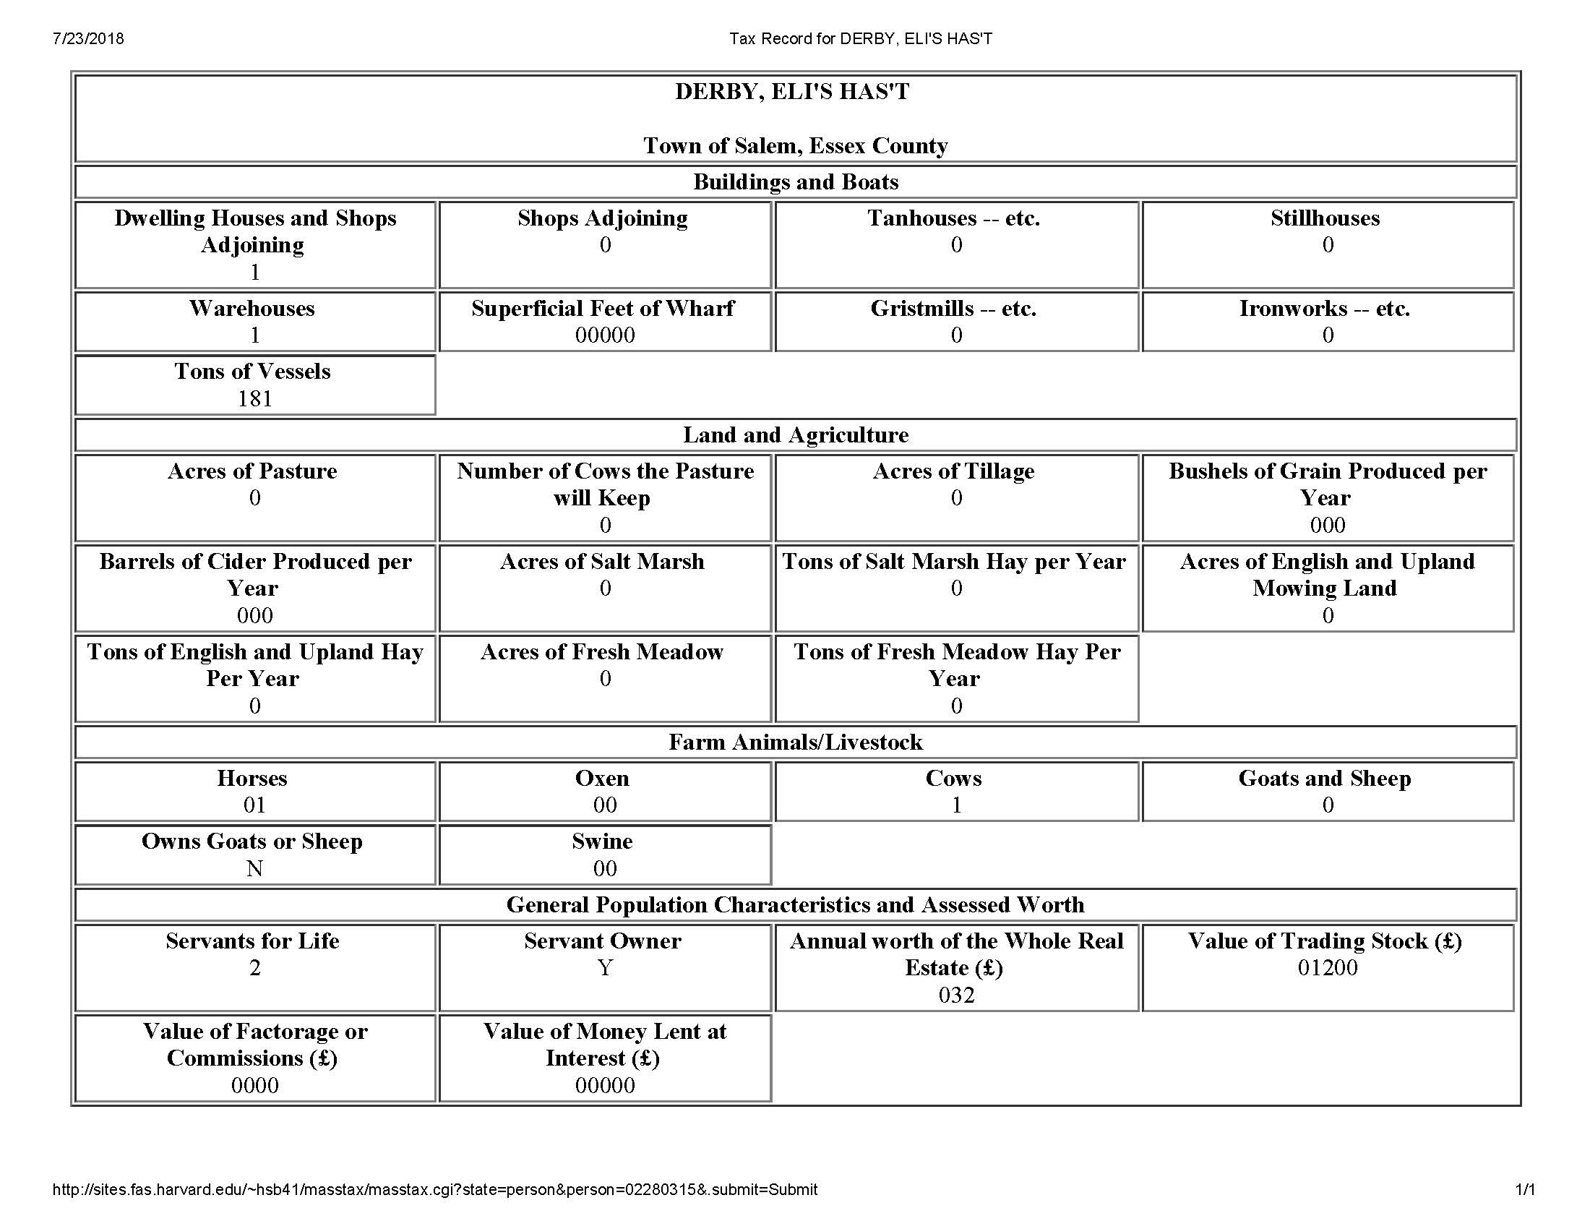
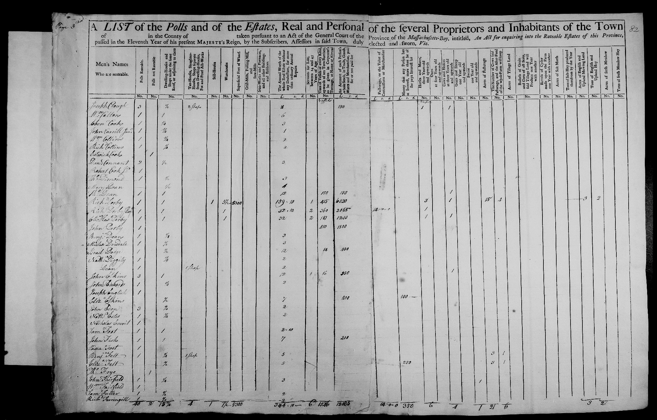

1771 Massachusetts Tax Inventory

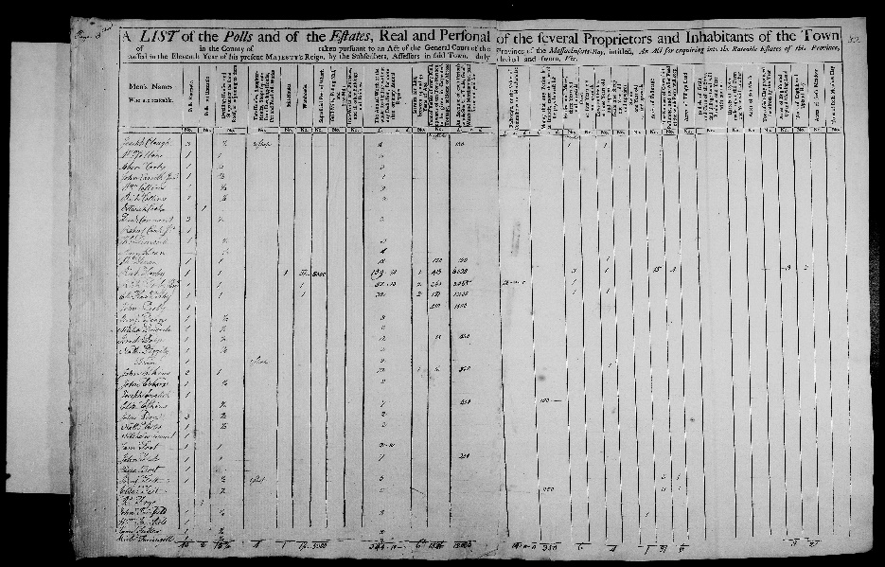

Citation and Credit:

Massachusetts State Archives collection, colonial period, 1622-1788; v. 134 -- Valuation of Towns, 1771.

Transcription

Servants for Life,
between 14 and 45
Years of Age

Richard Derby 1
Richard Derby, Junior, Esquire 2
Elias Hasket Derby 2
John Derby 0

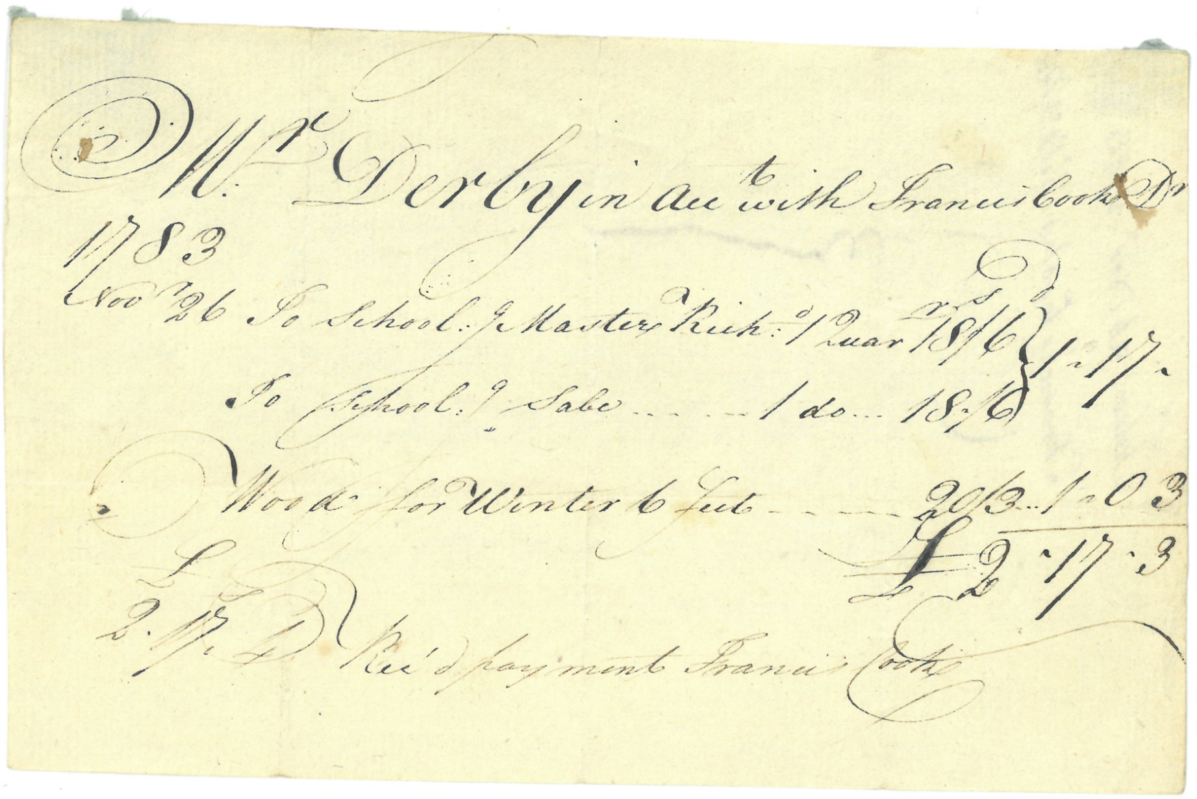

1783 Receipt for Schooling Sabe

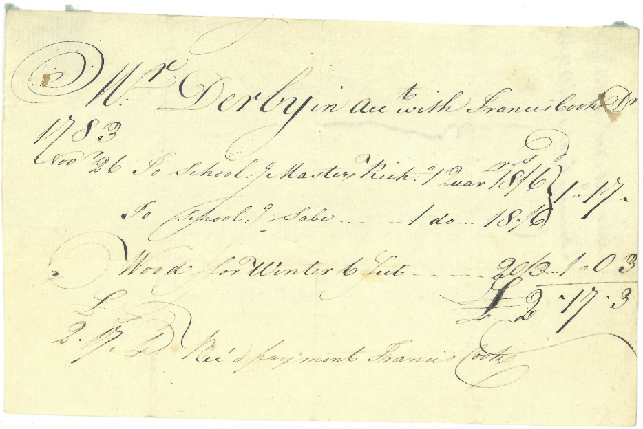

Citation and Credit:
Derby Family Papers, MSS 37, Box 17, Folder 1
Courtesy of The Phillips Library, Peabody Essex Museum, Salem, Mass.

Transcription

Mr. Derby in account with Francis Cook
1783
Nov. 26 To schooling Master Richard . . 1 Quarter
To schooling Sabe . . . . . . . . . . . 1 ditto
Wood for Winter 6 feet . . . . . .

Received payment Francis Cook

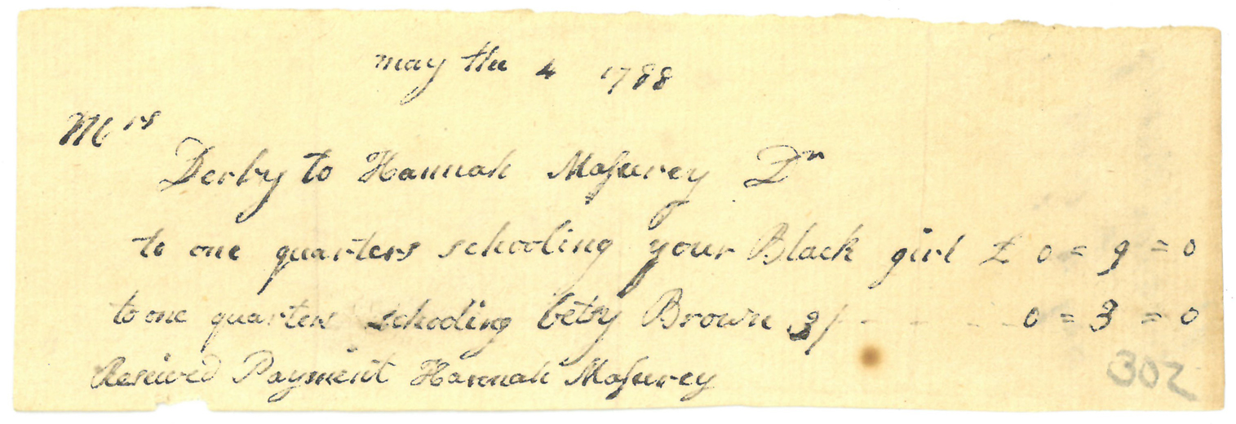
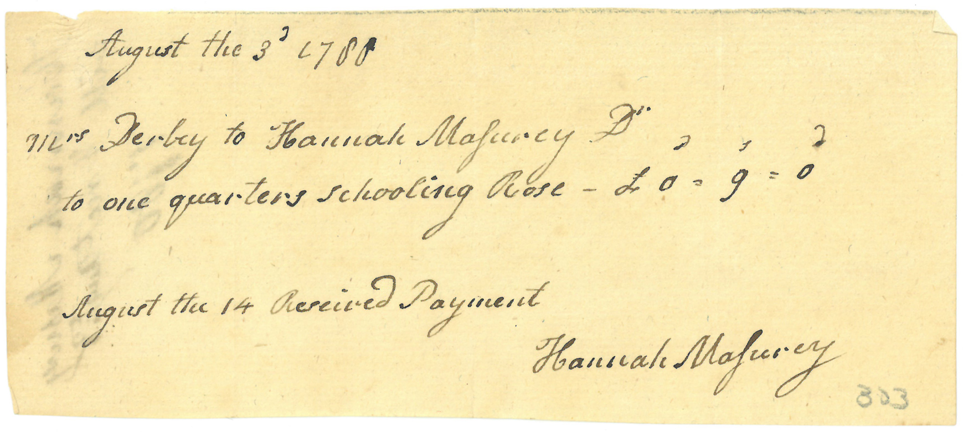
1788 Receipts for Schooling Rose

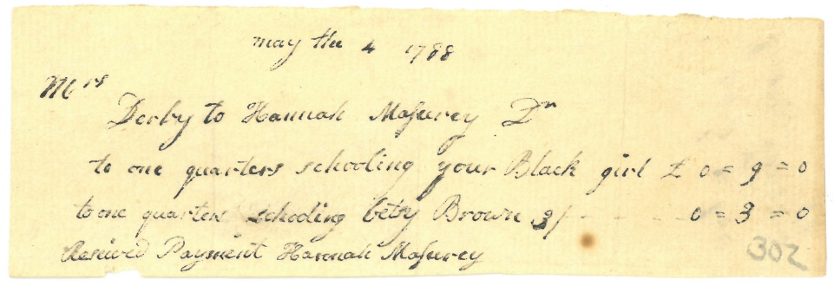

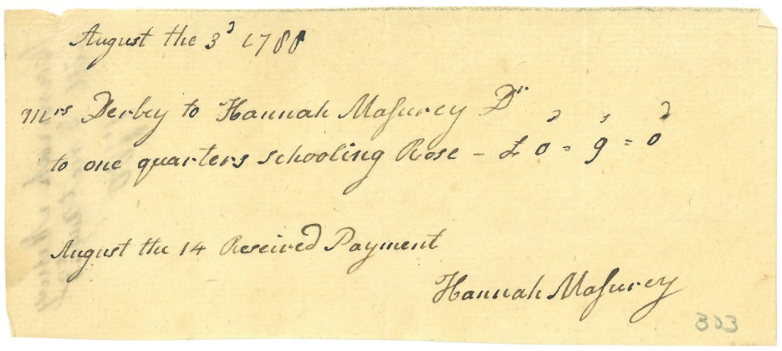

Citation and Credit:
Derby Family Papers, MSS 37, Box 17, Folder 4
Courtesy of The Phillips Library, Peabody Essex Museum, Salem, Mass.

Transcription

May 4, 1788
Mrs. Derby to Hannah Masurey
to one quarter schooling your Black girl £ 0 = 9 = 0
to one quarter schooling Betsy Browne 3/ . . .0 = 3 = 0
Received Payment Hannah Masurey

August 3, 1788
Mrs. Derby to Hannah Masurey
to one quarter schooling Rose - £ 0 = 9 = 0

August 14 Received Payment
Hannah Masurey

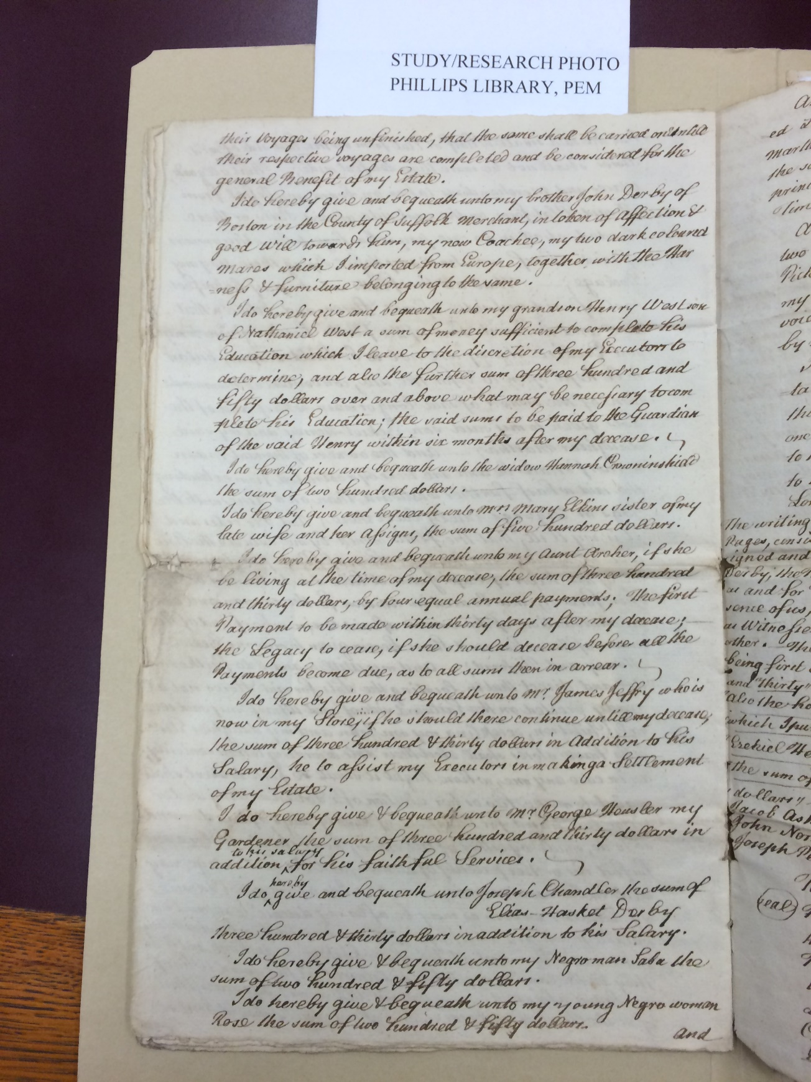

1799 Will of Elias Hasket Derby, page 1

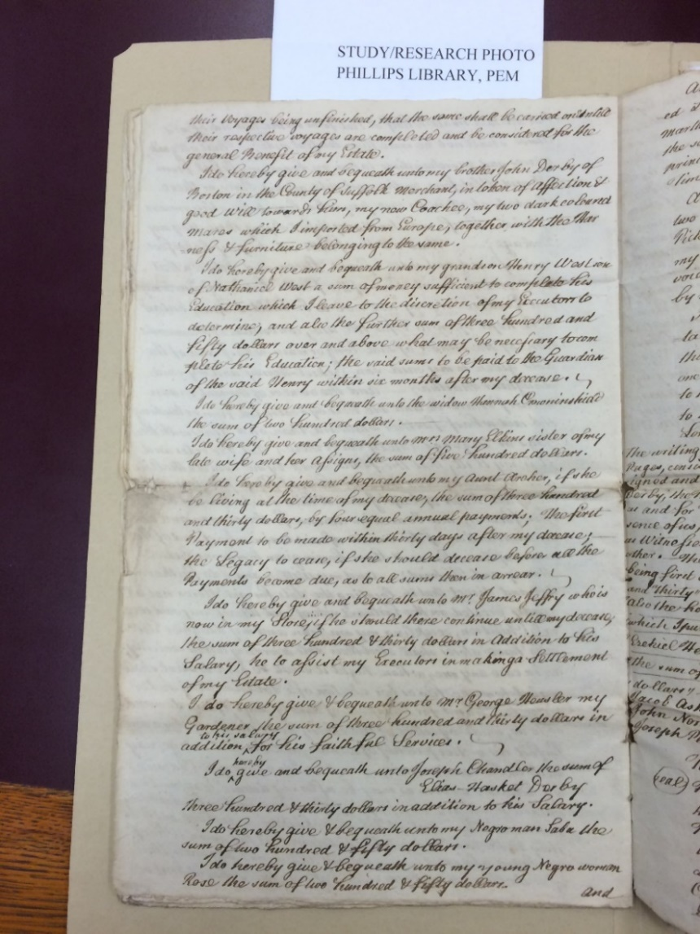
Citation and Credit:
Derby Family Papers, MSS 37, Box 19, Folder 1
The Phillips Library, Peabody Essex Museum, Salem, Mass.

Transcription

I do hereby give & bequeath unto my (Black) man Saba the
sum of two hundred & fifty dollars.
I do hereby give & bequeath unto my young (Black) woman
Rose the sum of two hundred & fifty dollars.
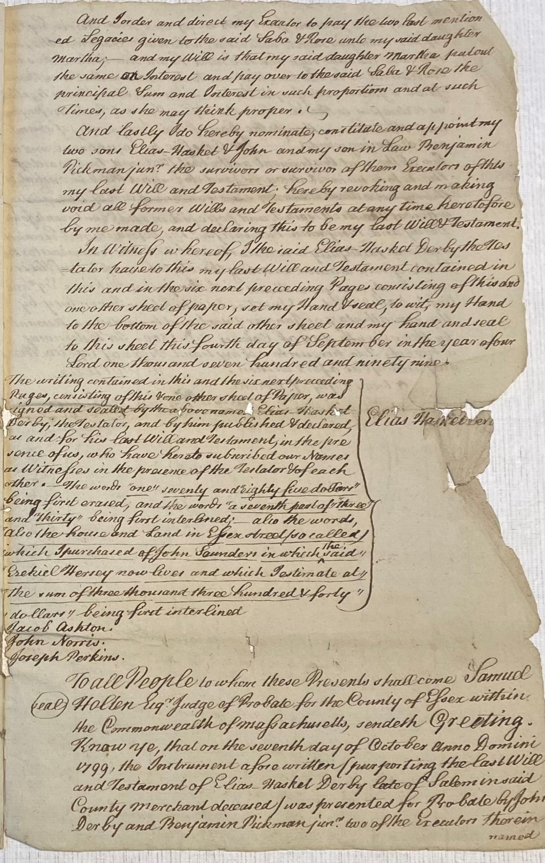

1799 Will, page 2

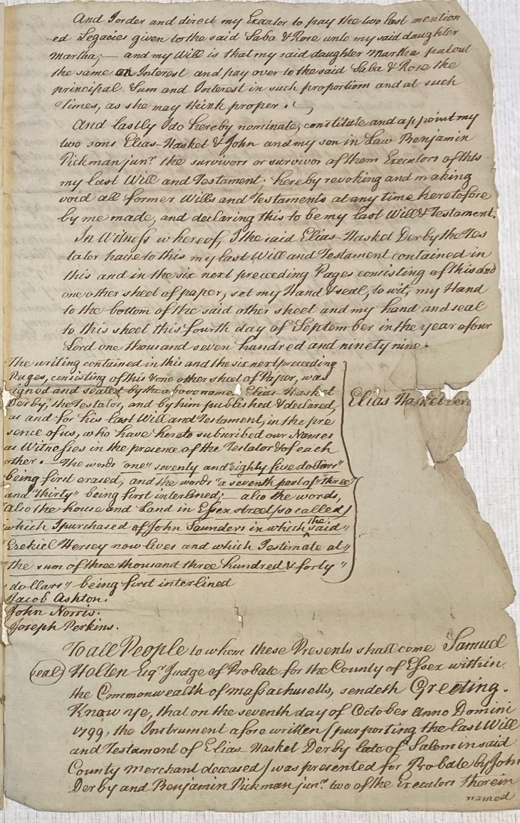
Citation and Credit:
Derby Family Papers, MSS 37, Box 19, Folder 1
The Phillips Library, Peabody Essex Museum, Salem, Mass.

Transcription

And I order and direct my executor to pay the two last mentioned legacies given to the said Sabe & Rose unto my said daughter Martha. . .
and my will is that my said daughter Martha put out
the same on interest and pay over to the said Saba & Rose the
principal sum and interest in such proportions and at such
times, as she may think proper.

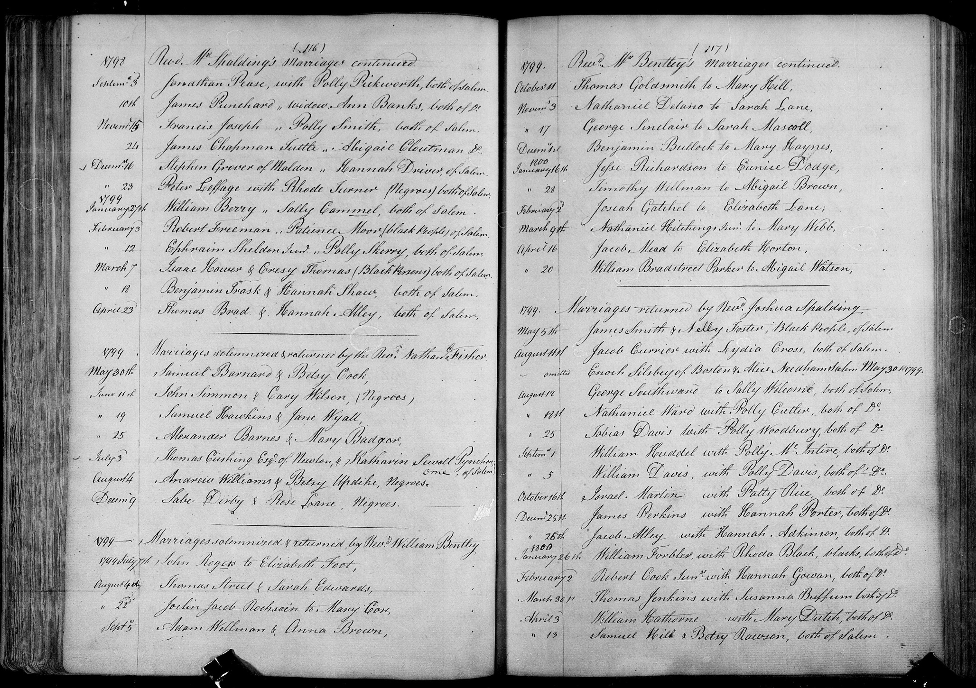

1799 Marriage Record of Sabe Derby & Rose Lane

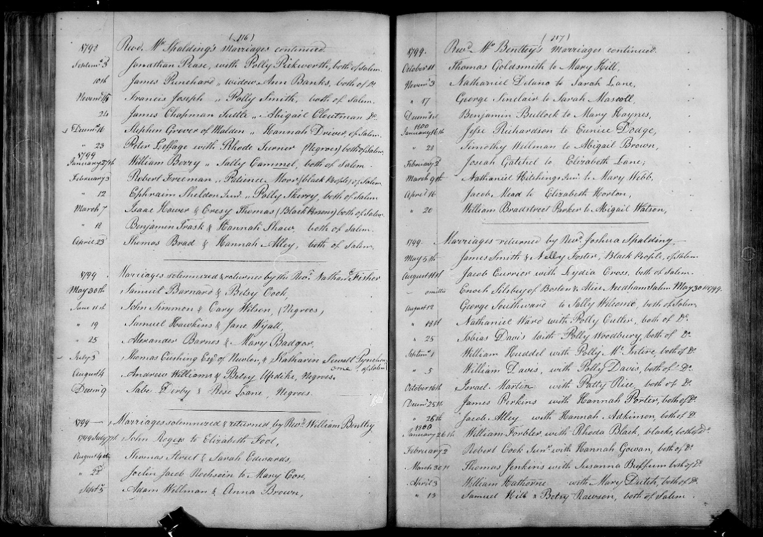

Citation and Credit:
“Massachusetts, Town Clerk, Vital and Town Records, 1626-2001," database with images, FamilySearch, Essex > Salem > Marriages 1695-1815 vol 4 > image 62 of 191; citing Massachusetts Secretary of the Commonwealth, Boston.

Transcription

December 9 Sabe Derby and Rose Lane, [Black, people of color]
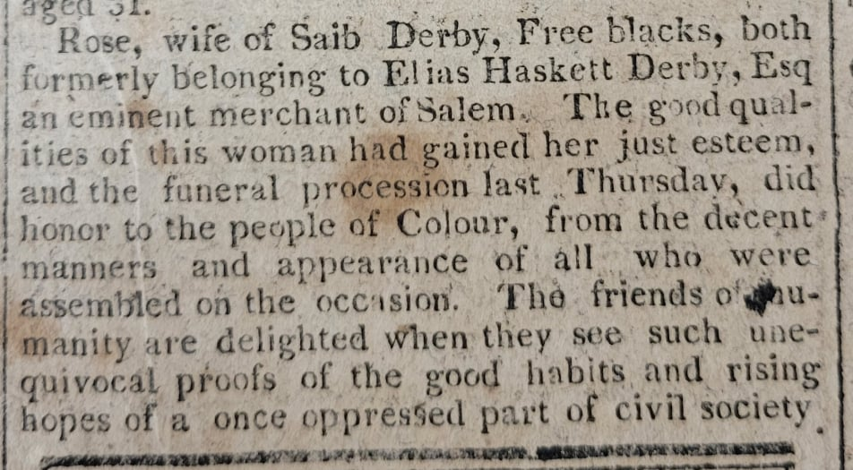

1809 Death Notice for Rose

Citation and Credit:
Essex Register, June 3, 1809
Courtesy of Museum of Printing, Haverhill, Mass.

Transcription

Rose, wife of Saib Derby, Free blacks, both formerly belonging to Elias Hasket Derby, Esquire an eminent merchant of Salem. The good qualities of this woman had gained her just esteem, and the funeral procession last Thursday, did honor to the people of color, from the decent manners and appearance of all who were assembled on the occasion. The friends of humanity are delighted when they see such unequivocal proofs of the good habits and rising hopes of a once oppressed part of civil society.

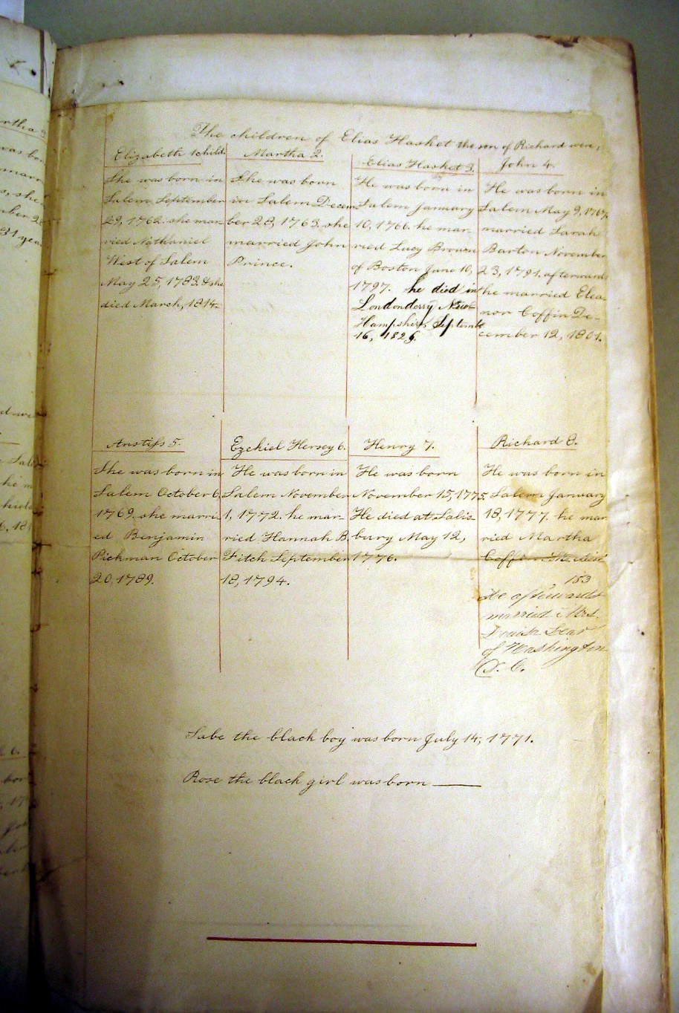

Undated Derby Family Genealogy

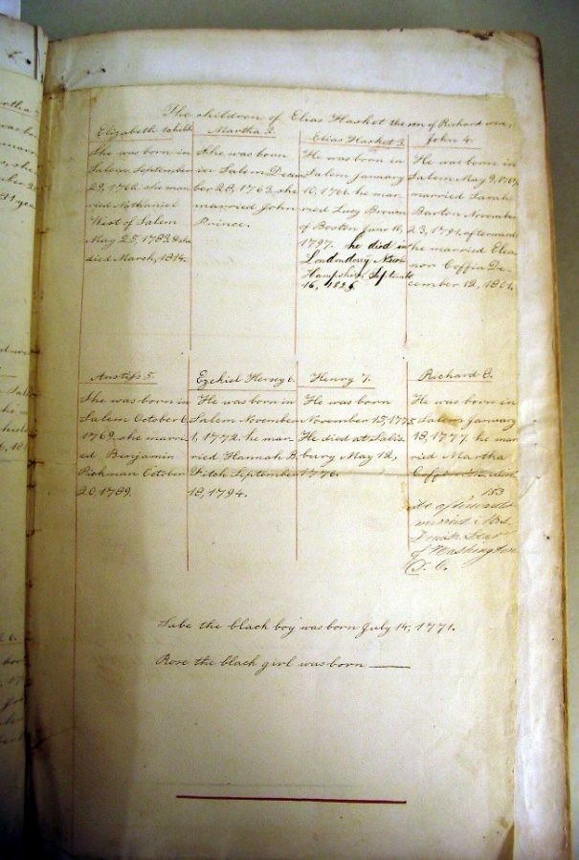
Citation and Credit:
Scan of the Derby family genealogy in the second volume of The Universal Bible or Every Christian Family’s Best Treasure, by S. Nelson. National Park Service Museum Collections, SAMA 3933.

Transcription

Sabe the black boy was born July 14, 1771
Rose the black girl was born ____________

